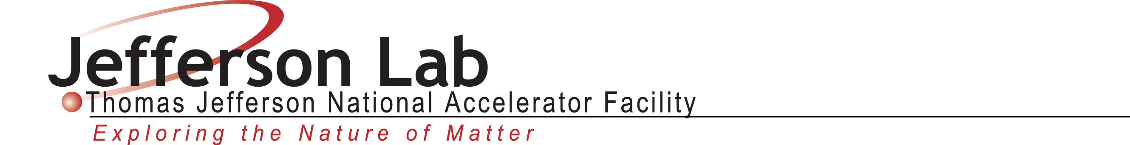

CORRESPONDENCE TO DOE - LOG SHEET

Log Number:

(Sign in binder located in CEBAF Center, Room B203)

To:

From:

Subject:

Document Author(s) Date

